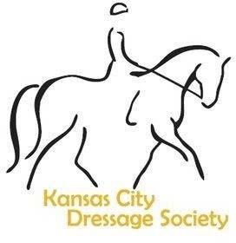KCDS Score-Report Form

This is a year-end awards program geared to KCDS members who are competing at the schooling and recognized level. Complete the form by filling out for each horse/rider combination.

You are strongly encouraged to complete the form on a computer and email. Remember to list equivalent levels.

Attach the image of the front of the test showing scores or attach score confirmation from USDF with the scores you are using circled CLEARLY.

Email (1) this FULL form with front page filled out completely, (2) Volunteer Hours Documented
and (3) Proof of Score
POSTMARKED ON OR BEFORE OCTOBER 20th, 2023 to:

Schooling Show Division: Brandi Sangster  1319 S Huntington Dr  Greenwood, MO 64034 | Recognized Show Division: Brandi Sangster  1319 S Huntington Dr  Greenwood, MO 64034
bsang7@yahoo.com | bsang7@yahoo.com

Your Name

Birthdate (needed for Juniors and over-50 only for perpetual award considerations)
/ /

Phone #

Date of 2023 KCDS Membership

Horse’s Name

Your Competition Division JY/YR n AA n OPEN n

Scores for KCDS Awards Schooling Shows:
(any score from a Region 4 (KS, MO, NE, IA, ND, SD and MN) Schooling Show may be sent in) but one of your three MUST be a score earned at a KCDS-hosted schooling show.)

Class Level | Show Name/Date | Score 1 | Score 2 | Score 3

Scores for KCDS Awards RECOGNIZED Shows:

Class Level | Show/Date | Score 1 | Score 2 | Score 3 | Score 4 | Equivalent Class Level

Your name: Vet of the Year: Farrier of the Year:
Trainer of the Year:

