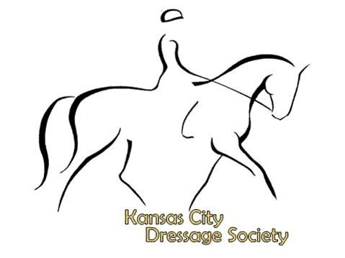
KCDS Membership Application 2024
Membership Dues: Please check
_____$63 Individual (1 vote)
_____$89 Family (2 adults - 2 votes or 1 adult and 1 junior - 1 vote)
_____$57 Junior (under 21 years on January 1 (Non voting Member)
Individual, Junior or Family Primary Member (Please print)
Name: Renewal? Junior?  Last, First Mi |  |  |  | USDF member #:
Address: City: St/Zip:
Telephone: Home- Cell- Work-
Email:
(please print)
Birth Date:
-Birth date is required for all Junior members (age 21 and under) and is requested by USDF for all other members.
Add Family Members (same address) (Please print)
Name1: Renewal? Junior?  Last, First Mi |  |  | Birth Date:
Telephone: Home- Cell- Add $26 for Family Membership
Email: USDF member #:
Name2: Renewal? Junior? Birth Date:
Last, First Mi
Telephone: Home- Cell- Add $17 per additional Family Member
Email: USDF member #:

Join The Kansas City Dressage Society
Has your data changed from previous years?
Yes

No
I want to volunteer: Board Clinic Committee

For shows: Scorer Scribe Gate Runner
Awards Ring set-up/down
We accept PAYPAL! Go to www.Paypal.com then use kcdsinfo@gmail.com to pay. Add $2 per Paypal transaction.

Or make checks payable to: KCDS
Mail form and check to: Barb Patrick
7821 SE Delwood Drive
St. Joseph, MO 64507

Questions: bjp802@yahoo.com
KCDS is a USDF Group Member Organization.
Members automatically become USDF Group Members.
KCDS membership year is December 1 through November 30.
Established in 1973, the Kansas City Dressage Society (KCDS) is a non-profit tax exempt regional organization founded for the education of members and the public in the true meaning of dressage training and its practical application in all equestrian endeavors. Club activities include education, schooling and recognized shows, clinics, seminars, camps,
instructor programs and an annual awards program. We invite you to join us in supporting the sport of dressage in our area.
KCDS Membership Benefits Include:

- KCDS Horse show Year-End Awards program.
- Subscription to the USDF Connections magazine.
- All USDF GMO Member Perks.
- KCDS Email Blast and Facebook updates on events and more.
- Free classified ads on the website.
- Member discounts for educational events.
- Opportunity to serve on the KCDS Board of Directors and vote in all elections.

